Human development
Class:
Time:
Date:
Adolescent Development Process (12-13 years old)
Introduction
In this development process, the teenager has great emotional and physical changes that are coupled with mature thinking. The child is usually on his/her way to becoming a grownup/adult so they tend to be open-minded and it is important for them to observe healthy eating habits as they transition towards adulthood. Due to the development of the immune system, they tend to be prone to common illness and in case the conditions persist, it is advisable for them to seek medical attention e.g. from the paediatrician (BJORKLUND, D. A. V. I. D. F., 2012).
Identity vs. Role Confusion
According to the Erikson’s Stages, this process lies in the identity vs Role confusion, which has a basic virtue of fidelity at the age of 12-18 years (Scheck, 2014). In this stage, the teens develop a mind or a moratorium due to the morality learned as a child and they develop ethics as adults. The teens establish themselves in the society. They become independent and they begin to establish themselves in their careers, housing, relationships, marriage, financial status, families etc. Erikson identifies two developments at this stage which are;
- Occupational
- Sexual.
In this stage, the teens will examine and identify themselves in order to establish themselves in sexual life and occupation. Some will be quick to get into relationships, others might find themselves bearing kids etc. It is a reintegrated sense of self, appropriate sex role and establishing what one needs or want. In this stage, as Erikson states, teens might feel uncomfortable about their body, however, they have to adapt to the growing changes in their lives and body. Erikson claims that teens will accept themselves as they accept others in terms of ideologies and identity. This period, the teens experience different lifestyles e.g. sex, education, work and political activities. In case an adolescent fails to understand their role in the society, they might end up being confused and they may not be sure of what they want in the society. It is therefore important for the teen to establish themselves in order to avoid negative identity, feeling of unhappiness and rebellion (Scheck, 2014).
Teens develop a conscious sense via social interaction for example interaction with peer pressure groups in different platforms such as the social media. The stage is based on developing a personal identity and a strong sense of one's self-esteem. The teens tend to have a psychological conflict, major questions of who am I? The teens also have the basic virtue of fidelity in their social relationships. Teens behave in an impulsive and unpredictable process as they try to identify themselves. In this stage, parents influence the behaviour of teens to become important in the society (Scheck, 2014).
Development needs and changes
This process is very important in human development because it marks the end of childhood and joining adulthood needs a mature person in different areas such as communication, behaviour, and thinking. It calls for psychological independence whereby the teen is required to make critical decisions in life. The following development needs are key in this process.
- Physical development
Most of the teens will undergo physical changes in their bodies and mind as they go through this process. For example, boys and girls will grow pubic hair; girls will experience menstrual flow. The physical development brings about anxiety and excitement and change in feelings and behaviour (Bosacki, 2016).
- Cognitive development
At the age of 13 the teens grow up their minds and they are in better position to understand issues they come across in life. They develop mature ways of thinking and they are able to make critical decisions that will affect their lives.
- Emotional and social development
The teen grows emotionally and they are able to understand what they want and they ought to do in life. The teens are in a position to interpret their feelings as well. In this process, they tend to find themselves far away from their family members as they engage themselves independently to develop their future (Bosacki, 2016).
- Sensory and motor development
Teens need to eat healthy in this process as they grow their body physically and biologically. For example, boys will grow stronger and this called for a well-balanced diet in order to grow their bodies and minds.
The above development needs have been summarized in the table below;
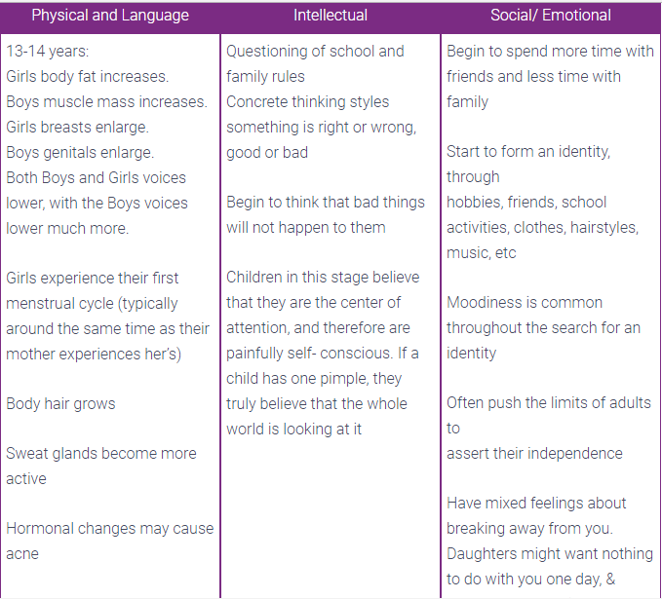
Why it is the most critical stage in human development
This stage is the most critical in the life of a human being. Human beings tend to transition from childhood to adolescent and establish themselves in the society. The stage defines the role of an individual in the society. It is the period when teens try to find out who they are in the society and the impact that they have on the society. It is a very critical stage that parents ought to take with a lot of seriousness because it builds the future of the teens as well as their health that is important in someone’s life (Newman, & Newman, 2015).

References
American Counseling Association. (2015). The ACA encyclopedia of counselling.
BJORKLUND, D. A. V. I. D. F. (2012). Child & adolescent development: An integrated approach. BELMONT: WADSWORTH.
Bosacki, S. L. (2016). Social cognition in middle childhood and adolescence: Integrating the personal, social, and educational lives of young people.
Escott-Stump, S. (2017). Nutrition and diagnosis-related care. 6th ed (KLIBF08/MWU-0199). Lippincott Williams & Wilkins.
Newman, B. M., & Newman, P. R. (2015). Development through life: A psychosocial approach. Belmont, Calif: Wadsworth/Cengage Learning.
Scheck, S. (2014). The Stages of Psychosocial Development According to Erik H. Erikson. München: GRIN Verlag GmbH.

